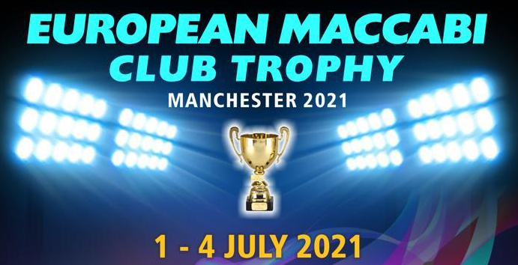
Dear All,
I would like to invite your club to participate in a fantastic football tournament taking place in Manchester, July 2021, with the winners being crowned Maccabi European Club Champions.
The tournament will be played out over three days of matches, starting on Thursday 1st July and finishing about 14:00 on Sunday 4th July.
Obviously we all find ourselves in the middle of a global pandemic, which makes planning for 2021 very difficult, but for now, all we are asking is that your club registers their interest in participating in the event. We will review matters as to Covid 19 across Europe and how this will impact on the event. We envisage that in March/April next year we may get the go ahead for the tournament to take place and it will be at this point that we will ask clubs to confirm that they will be joining us in July to participate in the event.
To register your interest, and to allow us to keep you up to date with tournament developments, please contact us either via email or through our website.
Below are a number of questions we anticipate you might ask with answers. These are not exhaustive. If you have any further questions or have any ideas that might assist with developing the event, then contact us via email, or should you wish to speak with us , please call us on +44 161 492 0040. Your call will be answered by the Club’s staff who will pass your details on to the Organising Committee for a return call. If your call is outside the Club’s opening hours then please leave a leaving contact details and that you are calling with regard to European Club Football Event.

Yours in Sport,
Tony Gellman
Manchester Maccabi
European Club Event Coordinator

Frequently Asked Questions
Q: When will the tournament take place?
A: The tournament will start on Thursday 1st July, and finish with a finals day on Sunday 4th July. All teams will play for a place, be it top place or last place on Sunday 4th July. Group games and knock out rounds will be played on Thursday and Friday. Finals Day will take place on Sunday no games on Shabbat.
Teams will be expected to arrive in Manchester on Wednesday 30th June, and leave after the Grand Final on Sunday 4th July which is expected to finish at 2pm.
Q: Sounds good – but how much will it cost?
A: We will be asking clubs to organise their own travel, accommodation and food arrangements in order to keep the costs down. Therefore we will only be looking for a charge to cover the cost of organising the tournament. We will do our best to keep these costs down, and will advise on this once we can confirm the competition is going ahead.
FOR NOW WE ASK CLUBS JUST TO REGISTER THEIR INTEREST IN TAKING PART.
Q: How much football will we play?
A: The number of matches will depend on the number of teams that enter. We envisage that all teams will play at least five games (two on Thursday, two on Friday and one on Sunday), but it could be up to 6. All games will be 11 aside, but the length of each game will depend on the number of games that need to be played.
Q: What surface will the games be played on?
A: We are hoping the games will be played on grass at Manchester Maccabi. Although Manchester is known for its rain, we are hoping that the weather will be good (as it usually is in July) and the pitches will be great to play on. However, in the event of wet weather we will move the tournament to an all weather surface as close to Maccabi as possible.
In terms of weather, the summer can be quite hot in Manchester and occasionally the temperature can be as high as 30°C. However it will more likely be around the average of 22/23°C during the competition.
Q: What is happening on Shabbat?
A: There will be no football played during Shabbat. We are looking at the possibility of hosting a Shabbat meal on Friday evening at Maccabi. Again we will confirm this once we know the tournament is definitely going ahead. We will provide all participants the opportunity of attending one of the many synagogues in Manchester on Saturday morning. Apart from that your time will be your own to explore Manchester and its diversity and cultural offerings.
Q: Where will the tournament take place?
A: The venue will be Manchester Maccabi Community & Sports Club. We have two full size grass football pitches, and additional space available for warming up prior to a game. We also have changing facilities and a large clubhouse.
Manchester Maccabi Community & Sports Club is about 4 miles outside the City Centre. It's easy to get to using public transport with the nearest tram stops (Bowker Vale or Heaton Park) less than a 10 minute walk away. It's also on a regular bus route and a taxi from Piccadilly (Central Manchester) will cost about £10.
Manchester Maccabi Community & Sports Club
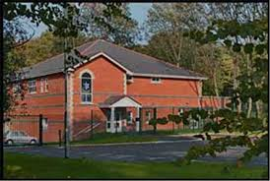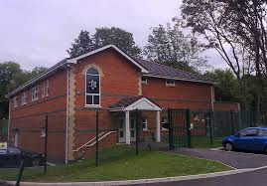

Google maps: MANCHESTER MACCABI COMMUNITY & SPORTS CLUB GROUNDS
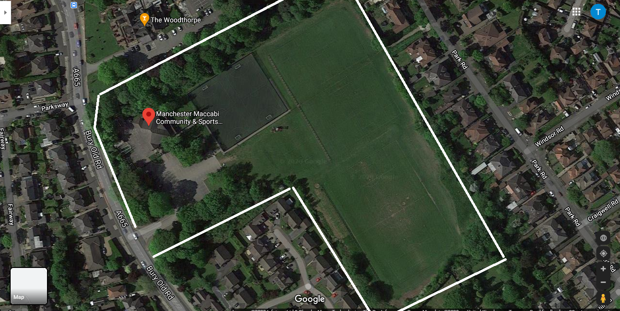

Q: What is Manchester like?
A: Manchester is a lively city brimming with character and steeped in its history. It’s deep tradition in music can boast the birthplace of The Smiths, Joy Division, Stone Roses, Oasis, and many others. It also has a proud sporting tradition, not just in football where it's home to two of Europe’s largest Clubs, Manchester City and Manchester United, but also plays host to large rugby and cricket clubs. Shopping is fantastic in Manchester City Centre with many shops and also the Arndale Centre and a few miles to the west of the City is the world famous Trafford Centre. The nightlife is also sensational with every form of entertainment on offer. The Northern Quarter is definitely worth checking out.
Q: Where will we stay?
A: Manchester has many hotels, all of different standards. Each clubs can pick their own. We plan to offer a range of hotels in the city centre, with which we have arranged preferential rates for participants in the tournament. We will also identify hotels near Manchester Maccabi (in Prestwich and Whitefield) should teams wish to stay locally to the club. Also there are a couple of Kosher hotels that we shall speak to and arrange rates if required. These will all be confirmed once we know the tournament can go ahead.
Q: Can I keep Kosher?
A: Yes. The food which will be available at Maccabi will be Kosher and under the Manchester Beth Din. Furthermore, there are a number of Kosher restaurants in the local area (mainly in Prestwich) where you can sit and enjoy a meal. There are also Kosher takeaway facilities in the area as well.
Q: How do I get to Manchester?
A: Transportation links to Manchester are first class.
AIR - you can fly into Manchester. The airport is connected to the city centre by a superb rail link which is not expensive and takes about 15 minutes. It is also possible to get the tram but this takes longer. Taxis from the airport aren’t cheap. It might also be advantageous to fly into Liverpool which is about 45 minutes drive from Manchester. If this would be your preferred route it might be necessary to arrange a minibus to transport you to Manchester. We can look into this if needed.
RAILWAY – Manchester has two mainline stations, Piccadilly and Victoria. They are both main line stations and are both in the heart of the city. One or the other of the Manchester stations are accessible from all major cities in the UK.
ROAD - Manchester has an extensive motorway network, should you choose to come by car. Parking can be quite expensive in the city centre, although an option could be to park at Maccabi, and use public transport to get to your accommodation.
Q: Interested? What next?
A: REGISTER YOUR CLUB’S INTEREST IN ENTERING THE TOURNAMENT BY EMAILING manmaccabifc@gmail.com or FILL IN YOUR DETAILS ON OUR WEBSITE, http://manchestermaccabi.org.uk/mect.
If you WANT to speak to us about anything please call +44 161 492 0040.
Your call will be answered by the Club’s staff who will pass your details on to the Organising Committee for a return call. If your call is outside the Club’s opening hours then please leave a leaving contact details and that you are calling with regard to European Club Football Event.

